AWS SysOps Administrator- Associate Level Setting up a website on Cloud
Description
You are a Cloud engineer. Your company has brought in a new client who has got a website. However, they need a web server so that they can run their website completely on Cloud. Once the web server is up and running, they want you to configure the Cloud so that testing of the web server can be completed successfully.
Steps to Perform:
- Create an EC2 instance (OS: Windows 2012 R2 Base)
- Install IIS server role
- Create a static website and check on a localhost
- Create an image of the machine and save the AMI
- Create a new instance using the AMI you have saved
- Create a Load Balancer and attach the instances you have done before
- Check the DNS name on the browser

Step 1 – Create an EC2 instance
What is happening: An EC2 instance is a virtual server running in Amazon's data centre. Here we launch a Windows Server machine that will become the web server, and open the firewall so that web traffic on port 80 and remote desktop traffic can reach it.
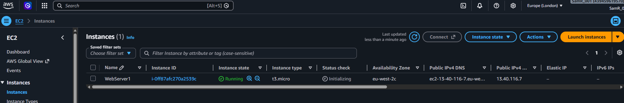
Note (OS: Windows 2012 R2 Base no longer exists this is Microsoft Windows Server 2022 Base from the Quick Start list
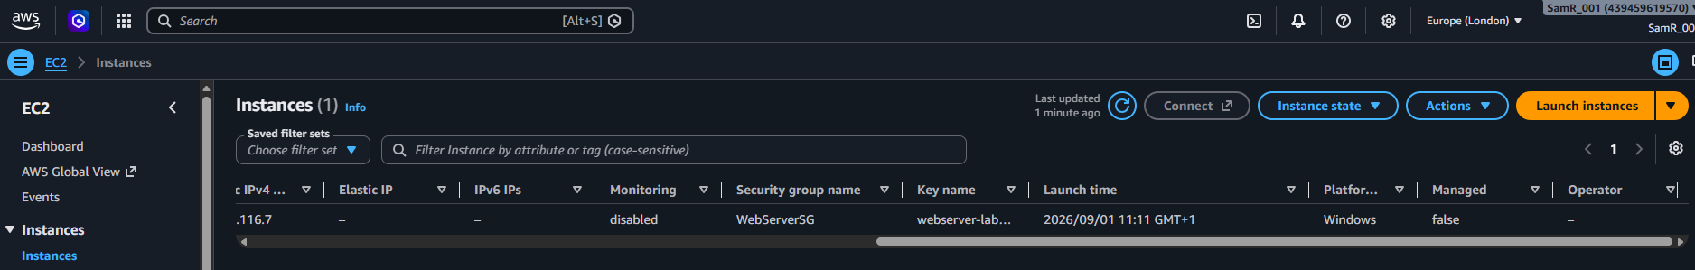

Step 2 – Install the IIS server role
What is happening: IIS (Internet Information Services) is the web server software built into Windows. Installing the Web Server (IIS) role turns the plain Windows machine into something that can serve web pages over HTTP.
Installing….
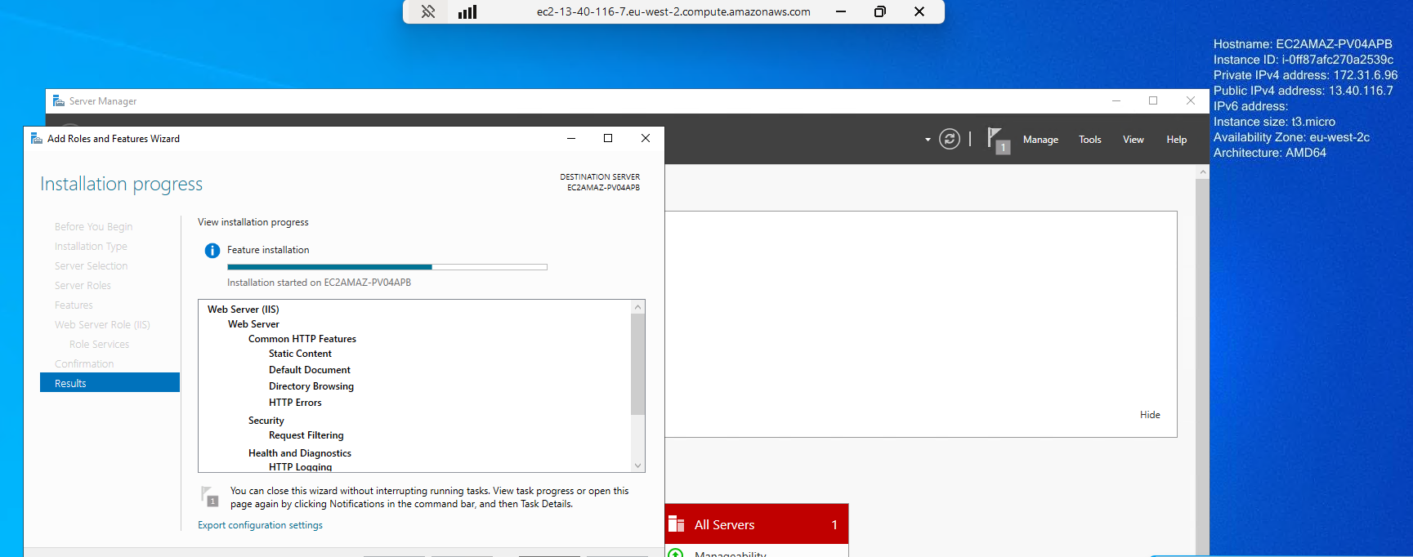
IIS Server Role Installed
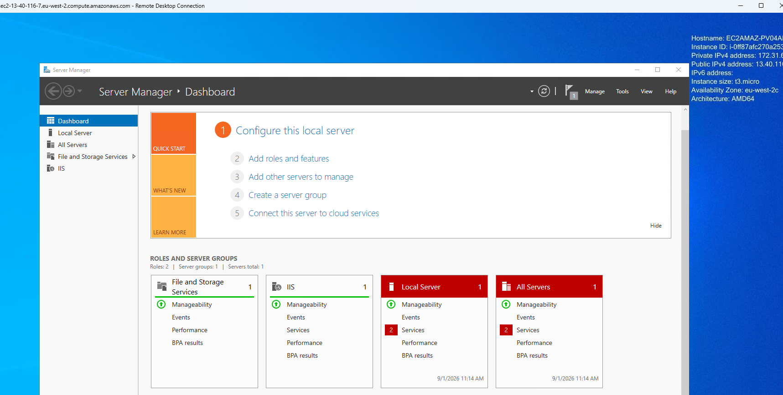

Step 3 – Create a static website and check it on localhost
What is happening: IIS serves files from the folder C:\inetpub\wwwroot. By putting our own index.html into that folder we replace the default IIS placeholder with the client's website, and browsing to localhost on the server proves the web server is working before we expose it to the internet.
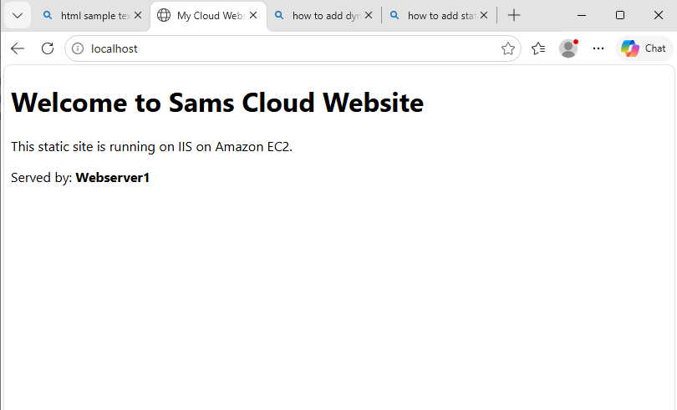
Step 4 – Create an image of the machine and save the AMI
What is happening: An AMI (Amazon Machine Image) is a snapshot of the whole server – Windows, IIS, and the website files all together. Saving one means any number of identical web servers can be launched from it later without repeating the setup manually.
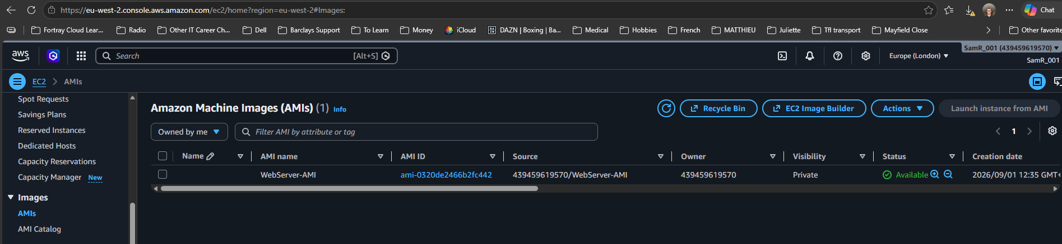

Step 5 – Create a new instance using the AMI
What is happening: Launching a second instance from the saved AMI produces a ready-made copy of the web server, already running IIS and already hosting the website. (note different AZ)
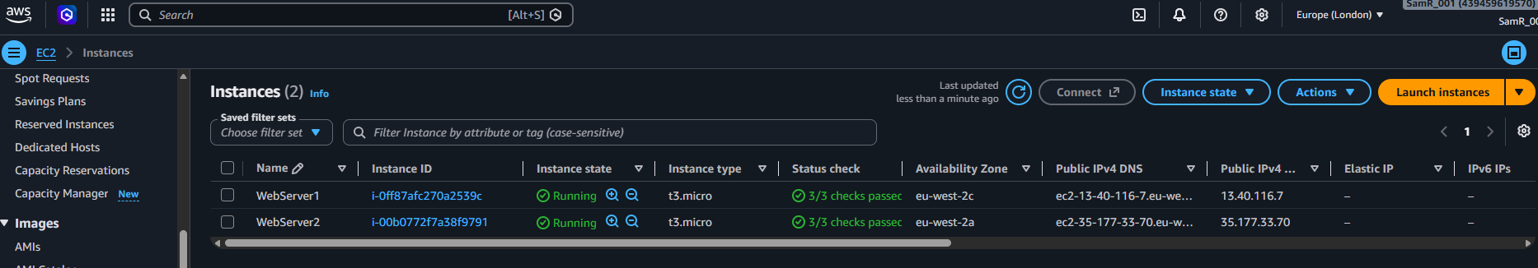
Then connect using Public Ipv4 Address
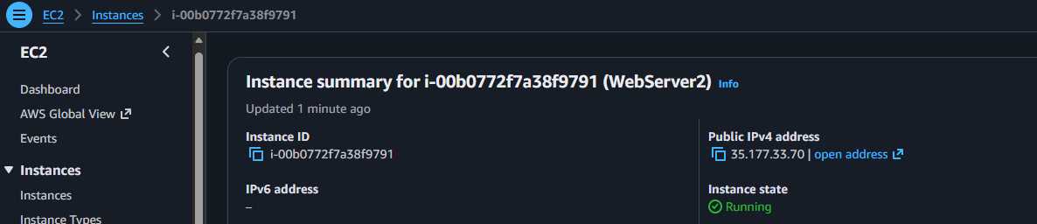
To show webserver 2 is working!
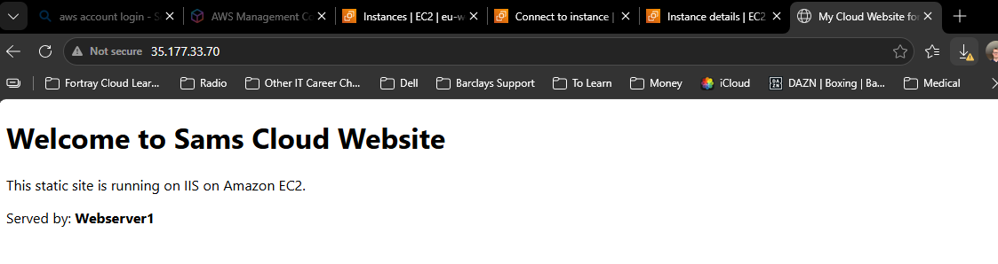
Step 6 – Create Load Balancer and attach Instances
What is happening: A load balancer sits in front of both web servers and shares incoming visitors between them. It also health-checks each server, so if one stops responding it stops sending traffic there and the website stays up.

- First Create Target Group - Containing Webserver 1 & 2
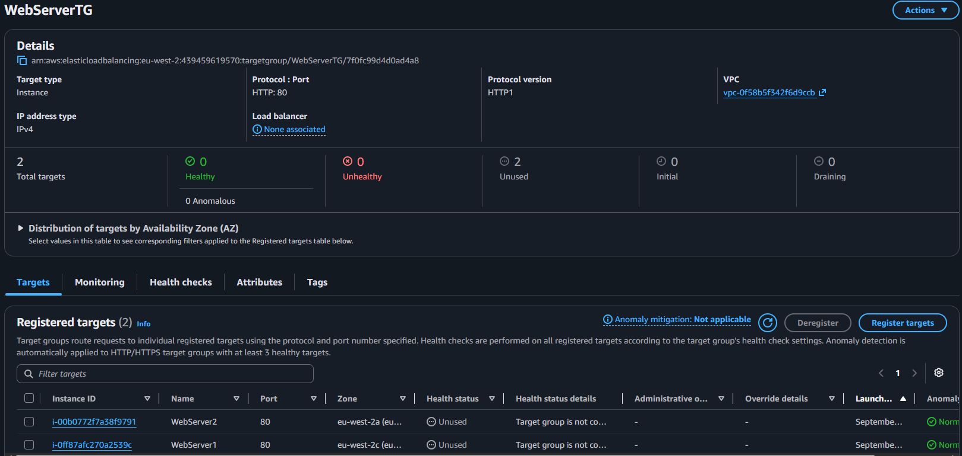

- Then create the load balancer
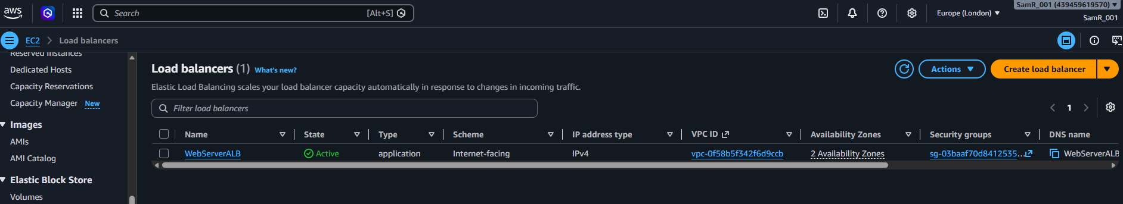

And Target group targets are “healthy”
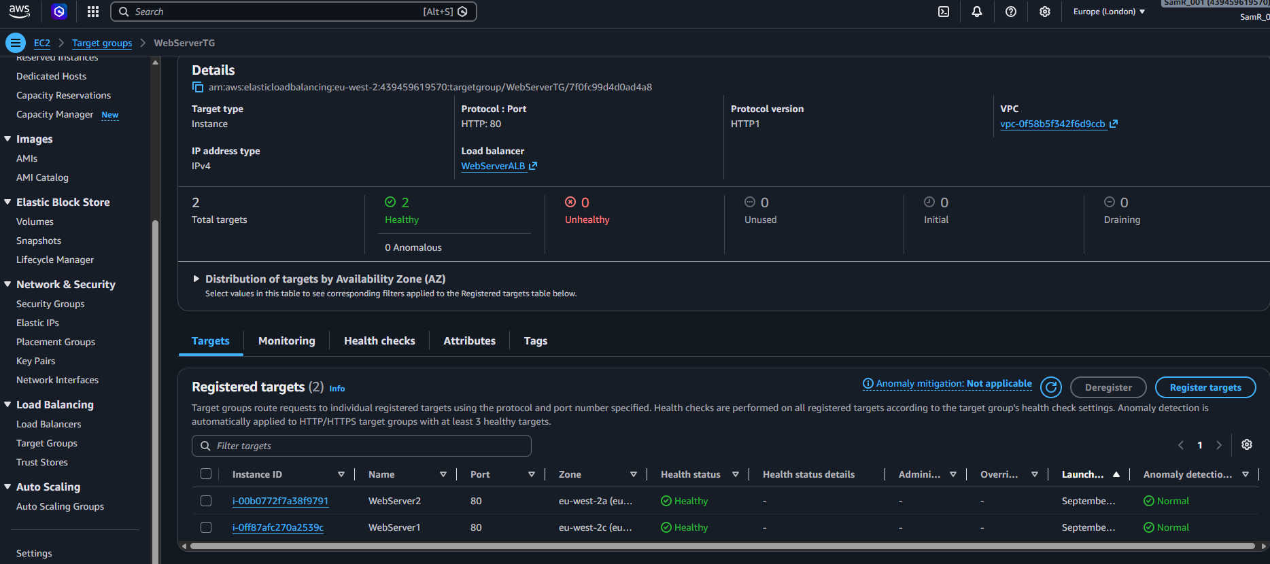

Step 7 – Check the DNS name in the browser
What is happening: The load balancer publishes a single public DNS name. Browsing to it proves the whole set-up works end to end: the request reaches the load balancer, which forwards it to one of the healthy web servers, which returns the website.

Copy ALB DNS name from here
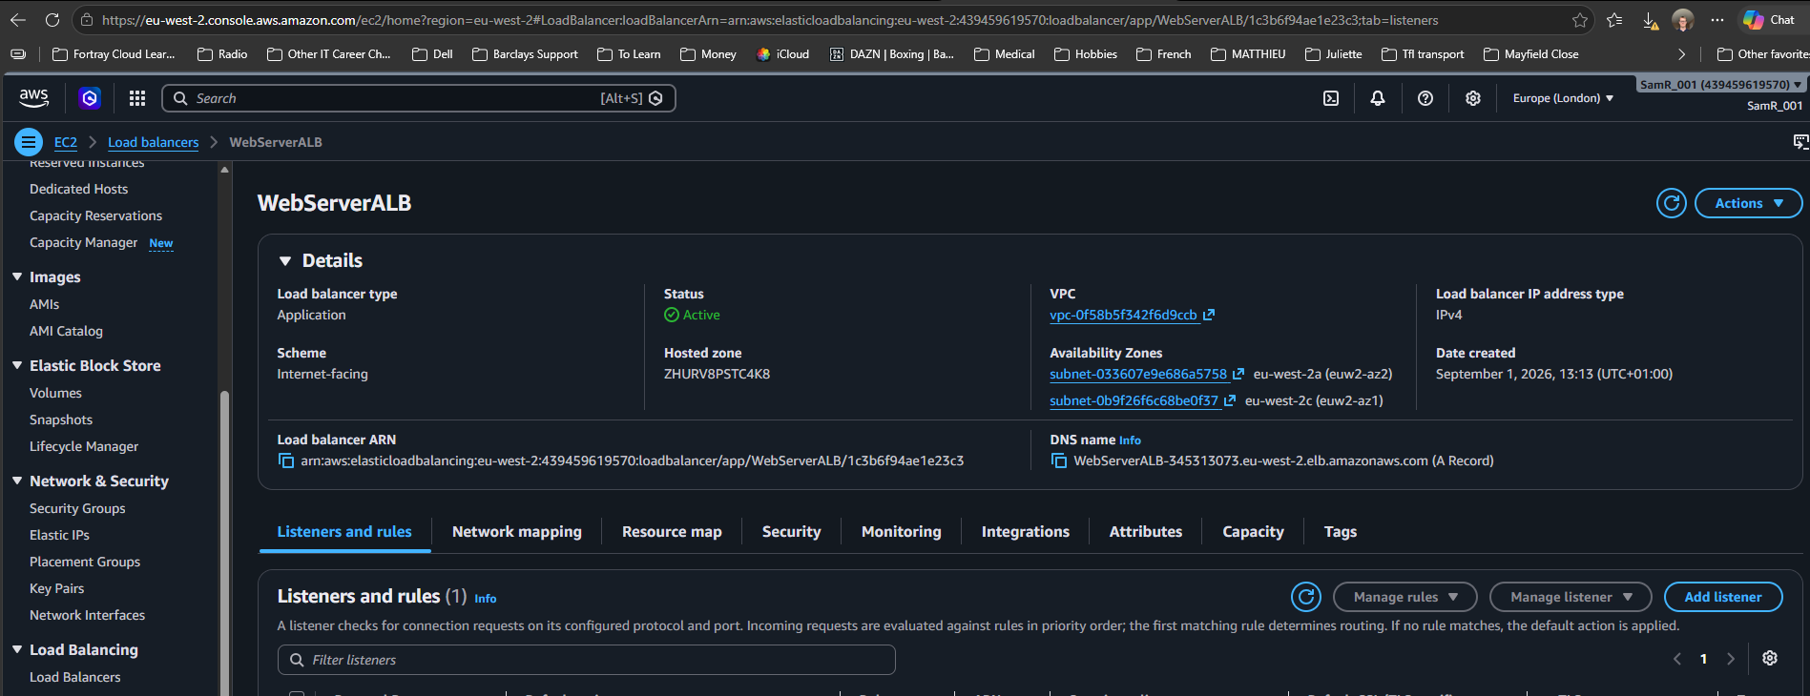

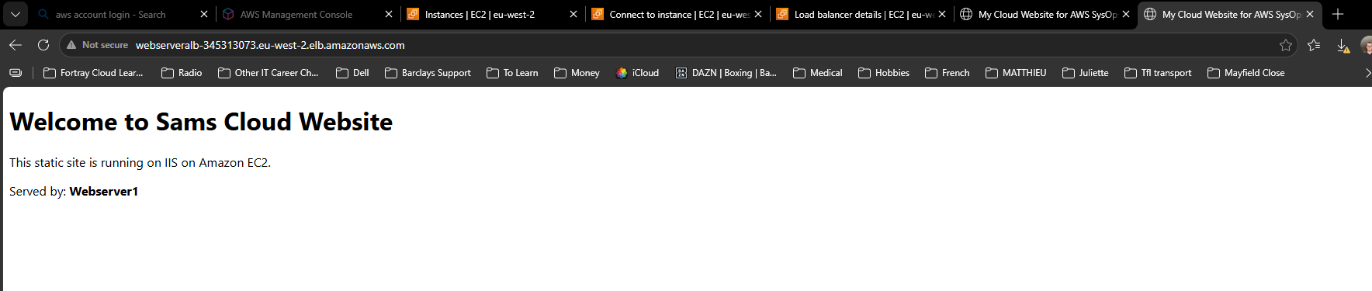
And confirm working!

